1. | The function y = x⁴+ bx²+ 8x + 1 has a horizontal tangent and a point of inflection for the same value of x. What must be the value of b?
2. | Let x and y be real numbers. What is the minimum value of the following function?  f(x, y) = $\sqrt{4+ y^{2}}+\sqrt{{\left(x-2\right)}^{2}+ {\left(2-y\right)}^{2}}+ \sqrt{{\left(4-x\right)}^{2}+1} ?$
3. | For some real numbers a and b, the equation 8x³ + 4ax² + 2bx + a = 0 has three distinct positive roots. If the sum of the base 2 logarithms of the roots is 5, what is the value of a?
4. | 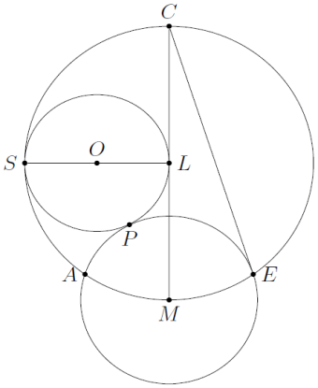  Three circles are situated as follows. The circle SPL has diameter $\overline{SL}$ and it is  centered at O; the circle APE is centered at M; and the circle CAE has  diameter $\overline{CM}$ and it is centered at L. The circle CAE is tangent to the circle  SPL at S and the circles SPL and APE are tangent to P. Also, $\overline{OL}$ $\overline{CM}.$  Find angle <MCE.
5. | 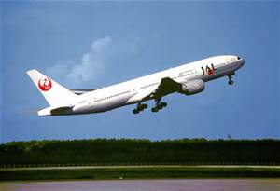  An airplane was supposed to cover the distance of 2900 km. However, after covering 1700 km, it had to land and wait on the ground for 1 hour and 30 minutes. After it took off again, its average speed was 50 km/h less than before. Find the original speed of the plane is it is known that it completed the flight 5 hours after departure.
6. | A horse on a carousel goes up and down 3 times as the carousel makes one complete rotation. The maximum height of the horse is 55 inches, and the minimum height is 37 inches. The carousel rotates once every 21 seconds. Assume that the horse starts and stops at its median height. Write an equation to represent the height of the horse h as a function of time t seconds and sketch the graph showing exactly 2 cycles. (Look at answer sheet for graph).
7. | In 1997, after Mark McGuire hit a home run, the claim was made that the ball would have traveled 38feet if it had not landed in the stands. The path of the baseball can be modelled by  y = –0.003x² + 1.77x – 1.72 and the stands can be modeled by y = $\frac{3}{7}x$ – 128.6. How far from home plate did the ball land in the stands?
8. | The lengths of the sides of a cyclic quadrilateral are 1, 9, 9, and 6, as shown in the diagram.  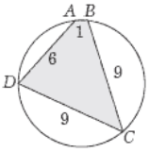  Find cosB.
9. | For what value(s) of a does the system of equations have exactly three solutions?  $$\left\{\begin{matrix}x^{2}= y^{2} \\ {\left(x-a\right)}^{2}+ y^{2}=1\end{matrix}\right.$$
10. | 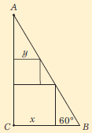  Given 30-60-90°, ΔABC with inscribed squares of side lengths x and y,  find x/y in simplest radical form.
11. | N and Y are positive integers. N ≠ Y. If N × Y ÷ 2 = N + Y, what is the sum N + Y?
12. | A real estate office handles an apartment building that has 50 units. When the rent is $540 per month, all units are occupied. However, for each $30 increase in rent, one unit becomes vacant. Each occupied unit requires an average of $18 per month for service and repairs. What rent should be charged to obtain the maximum profit?
13. | 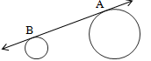  Two circles with radii of 8 cm and 3 cm, respectively, have a common external tangent that determines a segment AB of length 12 cm between the points of tangency. What is the distance between the centers of the circles?
14. | 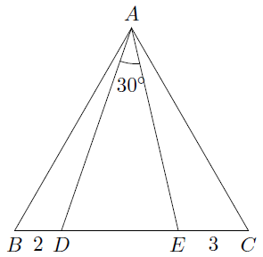  Let ΔABC be equilateral. Two points D and E are on side BC (with order B, D, E, C), and satisfy <DAE = 30°. If BD = 2 and CE = 3, what is the exact value of BC?
15. | If sinx + cosx = 1/5 and π/4 ≤ x ≤ π/2, find the numerical value of cos2x .
16. | Find the smallest possible simplified length for a diagonal of a rectangle with a perimeter of ten feet.
17. | The circles shown continue indefinitely and the largest circle has a diameter of 8. The diameter of each circle is half the diameter of the previous circle. What is the exact sum of the area of all the circles?
18. | How many triples (x, y, z) of rational numbers satisfy the following system of equations?  x + y + z = 0  xyz + z = 0  xy + yz + xz + y = 0
19. | If Ω = 2 + i, then in the form of a + bi, what does Ω⁴ + Ω^{–1} equal?
20. | A circular Ferris wheel has a radius of 8 meters and rotates at a rate of 12 degrees per second. At  t = 0, a seat is at its lowest point, which is 2 meters above the ground. Determine how high above the ground the seat is at t = 40 seconds.
21. | The quartic polynomial P(x) satisfies P(1) = 0 and attains its maximum value of 3 at both x = 2 and  x = 3. Computer P(5).
22. | If the minimum value of the function f(x) = cos(2x) – 2a(1 + cos(x)) is –½, then what is the exact value of a?
23. | I am trying to solve $\frac{4}{x-2}>5$. I use my calculator and mistakenly type a digit other than 5 when I type in the problem, so I get the wrong solution. My answer was 2 < x < 4. What digit did I mistakenly type in?
24. | A forester mixes gasoline and oil to make 2 gallons of mixture for his two-cycle chain-saw engine. This mixture is 32 parts gasoline and 1 part two-cycle oil. How much gasoline must be added to bring the mixture to 40 parts gasoline and 1 part oil?

